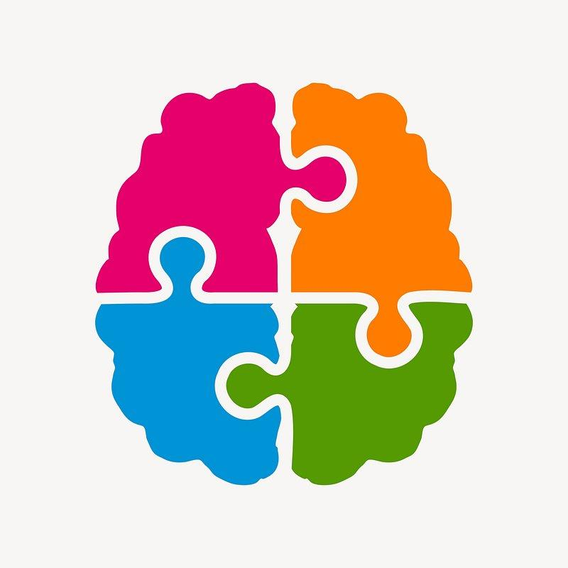**ONLINE ENRICHMENT ACTIVITIES FOR GIFTED STUDENTS**

**Click the picture for enrichment challenges**

**LOGIC PUZZLES** [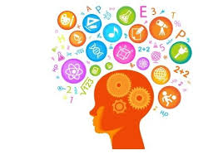](https://www.brainzilla.com/logic/logic-grid/)[****](https://daydreampuzzles.com/logic-grid-puzzles/)

**LOGIC GAMES** [****](https://www.safekidgames.com/logic-games/)[****](https://www.kidsmathgamesonline.com/logic.html)

**BRAIN TEASERS** [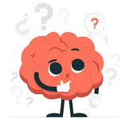](https://www.coolmath4kids.com/brain-teasers)[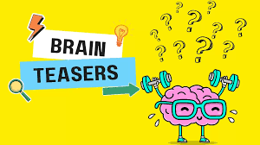](https://www.neok12.com/games.htm)

**MEMORY GAMES** 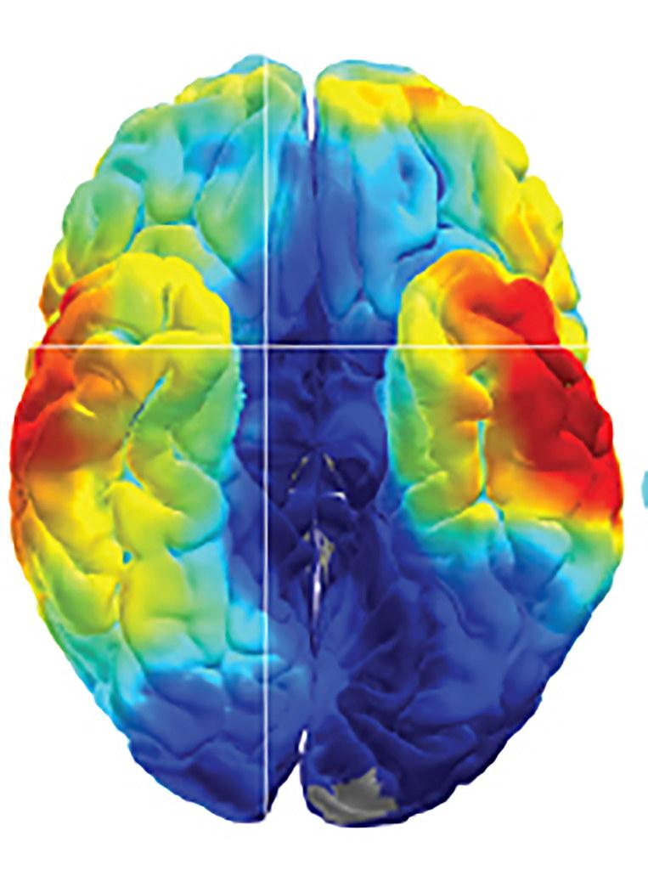

**Challenges are engaging, promote critical thinking and communication. They accelerate learning, improve self-reflection and increase motivation.**